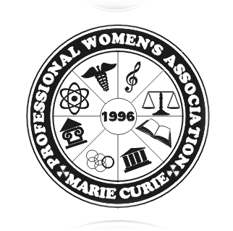
Marie Sklodowska Curie Professional
Women’s Association

Storytelling Contest 2024
January 10, 2024
TO: DIRECTORS OF POLISH LANGUAGE SUPPLEMENTARY SCHOOLS
Marie Sklodowska Curie Professional Women’s Association is currently planning a STORYTELLING CONTEST, which take place at The Kosciuszko Foundation (15 East 65th Street, New York, NY 10065) in March 17, 2024 (Sunday) at 10 am. Honorable Patronage - Centrala Polskich Szkół Dokształcających w Ameryce/ Polish Supplementary School Council of America, Inc The contest will be open to children 9 to 12 years of age from Polish Supplementary Schools. The contestants may choose any Polish Folktale (it must be originally from Poland). A folktale encompasses fairy tales, legends, fables and myths. A Polish poem which tells a story will be accepted. It is to be told in English or Polish. Time for each participant will be limited to no more than five minutes. Please limit participation from your school to 2 contestants (1 in Polish language, and 1 in English language). No group presentations will be allowed. Students who previously won first place, are not allowed to participate again.
Participants will be judged on pronunciation and enunciation, voice control, pacing, poise, audience contact and story selection. Enclosed you will find additional suggestions and contest rules. Each contestant will receive a Certificate of Participation, and a prize for taking part in the contest. Also the teacher who prepared the contestants and the school will receive a Certificate of Appreciation. Winners (in English and in Polish) will be awarded by money certificates. Your supplementary school may invite up to 4 guests in addition to each contestants (parents, teacher or sibling).
Please return the enclosed Participate Form on or before February 1, 2024 and Entry Form on or before March 1, 2024
We hope that this competition will encourage our children to improve their communication skills and enhance their pride in our Polish heritage. We are looking forward to meeting you and your students. If you have any questions, call Maria 917 771 7130 Very Truly Yours,
Maria Bielska

